**Defect Report**

* **Defect Id: 19**
* **Status: New**
* **Reported by: Bishoy**
* **Asserted to: Malek**
* **Date:**  **13/5/2023**

**Defect description: after entering a fraction value for student activity mark, an** *INVALID_STUDENT_ACTIVITIES_MARK* **exception must be thrown but nothing was thrown and the activity mark is stored successfully. Student activity mark must be an integer value ranges from 0 to 10**

* **Steps:**

1. **Open the application**
2. **Enter the student activity mark = 5.5**
3. **Run the program**

* **Severity: Medium**
* **Priority: High**
* **Screenshot for the Defect:**

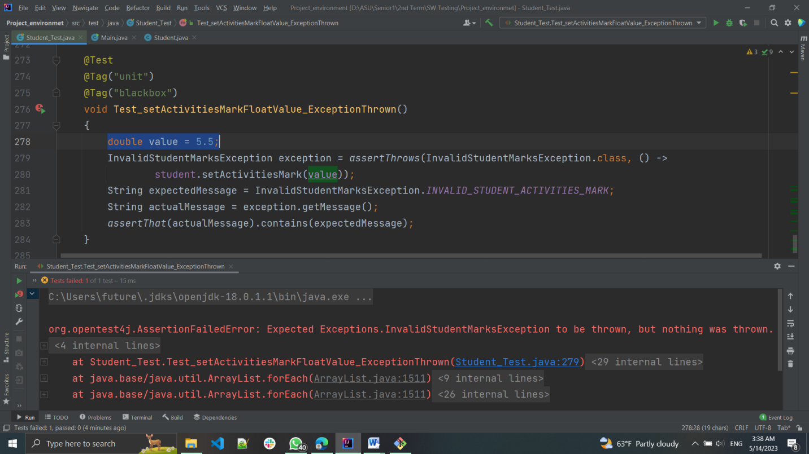

* **Screenshot after fixing:**